TASK 6
Practice tasks
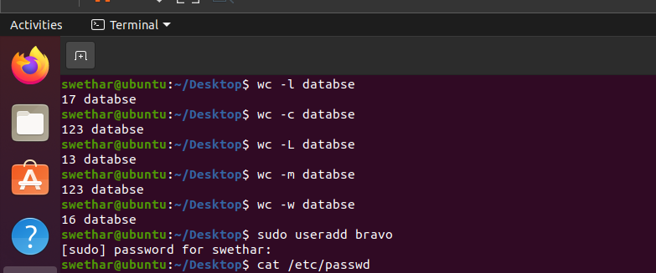
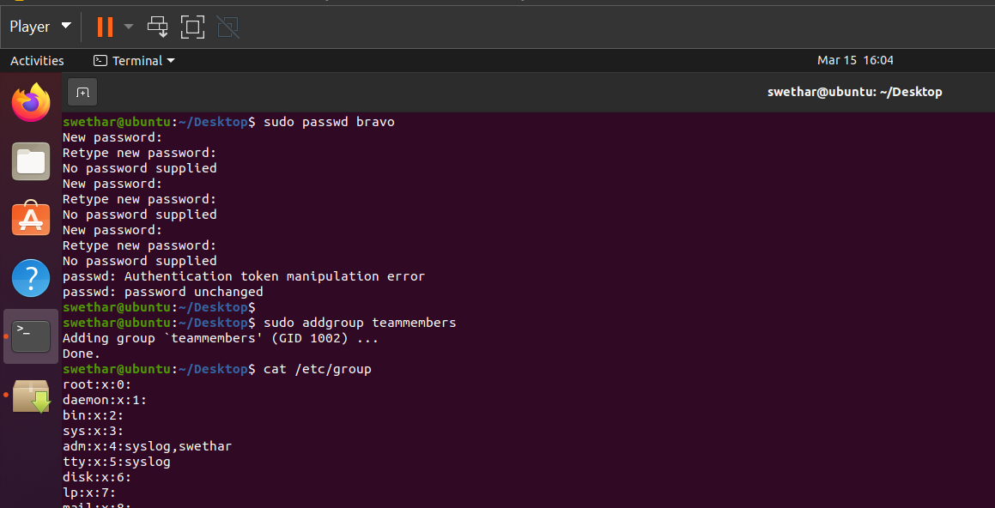
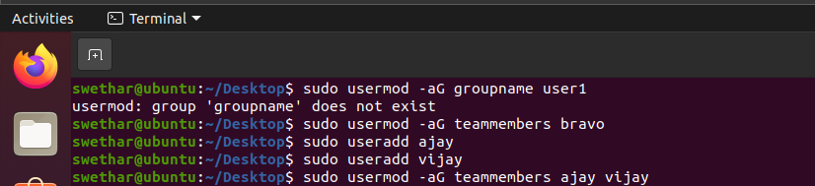
Additional tasks
1.How to add multiple users together to a group?
2.How to remove multiple users together from a group ?
